**SUMMARY**

During my internship at **Prodigy InfoTech**, I was entrusted with a variety of exciting tasks that helped me develop my web development skills and gain hands-on experience with real-world applications. Below is an overview of the key projects I worked on:

1. **Task - 1: Landing Page: Life of a Girl - Butterfly Stages**  
   The first project was the **Landing Page** titled *“Life of a Girl: Butterfly Stages”*. The page used the metaphor of a butterfly’s life cycle to represent the stages of a girl’s growth, emphasizing transformation and development.

* **Features:**
  + Visually appealing design with a smooth scrolling effect
  + Responsive layout that adapts seamlessly to different screen sizes
* **Technologies Used:** HTML, CSS
* **Skills Developed:** This task helped me focus on creating visually engaging designs and responsive layouts. It improved my ability to make content more interactive using smooth scrolling techniques.

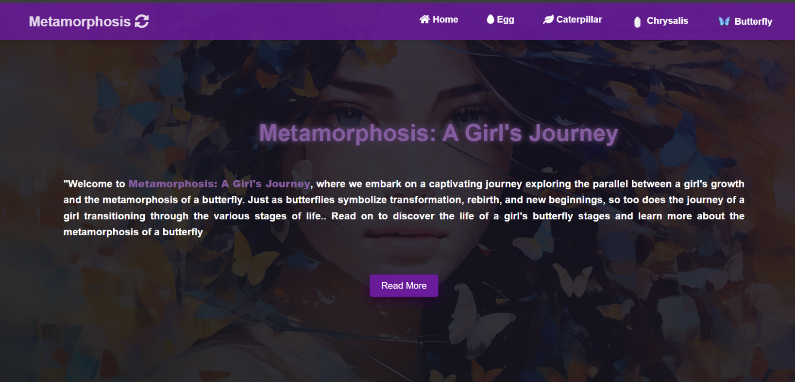**Screenshot**

1. **Task - 2: Stopwatch**  
   The **Stopwatch** project was a simple yet functional application where users could start, stop, and reset the timer.

* Features:
* Start, stop, and reset functionality
* Clean and user-friendly interface
* **Technologies Used:** HTML, CSS, JavaScript
* 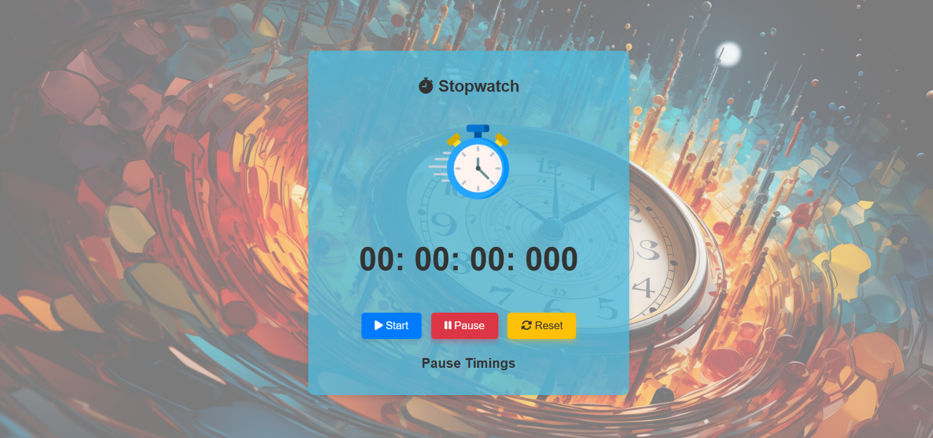**Skills Developed:** This project strengthened my understanding of JavaScript for handling user interactions, real-time updates, and DOM manipulation.

1. **Task - 3: Tic Tac Toe**  
   The **Tic Tac Toe** game allowed users to play against either a friend or an AI.

* **Features:**
  + Option to play against a friend or the computer
  + Simple, intuitive interface with a responsive design
* **Technologies Used:** HTML, CSS, JavaScript
* **Skills Developed:** This project helped me develop game logic and enhance my skills in JavaScript event handling and dynamic content updates.

1. A screenshot of a game

   Description automatically generated**Task - 4: Portfolio Website**  
   The **Portfolio Website** was a project to showcase my skills, projects, and accomplishments as a web developer. It included sections like *Home*, *About*, *Skills*, *Projects*, and *Contact*.

* **Features:**
  + Home section with a captivating headline, photo, and skill summary
  + About section with detailed background and professional experience
  + A skills section with icons and a list of technical and soft skills
  + Projects section showcasing my previous work
  + Responsive design and smooth scrolling animations
* **Technologies Used:** HTML, CSS, JavaScript
* 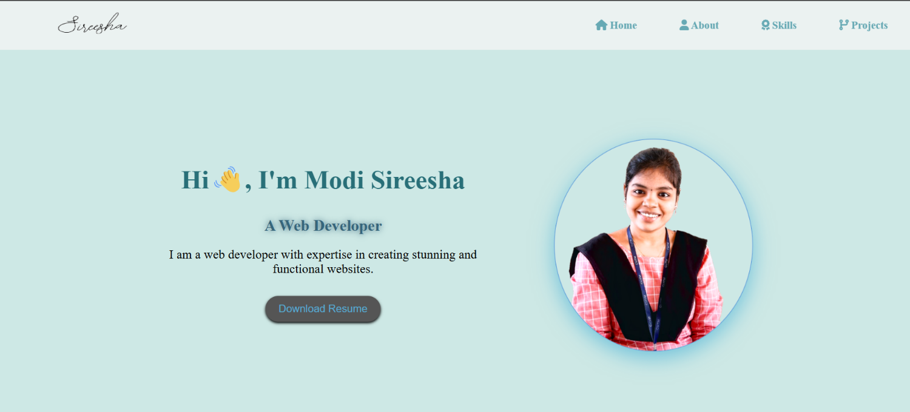**Skills Developed:** This portfolio allowed me to present my work professionally, enhancing my skills in design, web development, and personal branding.

1. **Task - 5: Weather App**  
   The **Weather App** was a real-time weather application that fetched weather information based on the user’s input location.

* **Features:**
  + Displays current weather conditions, temperature, and location
  + Responsive design for different screen sizes
* **Technologies Used:** HTML, CSS, JavaScript, Weather API (e.g., OpenWeatherMap)
* 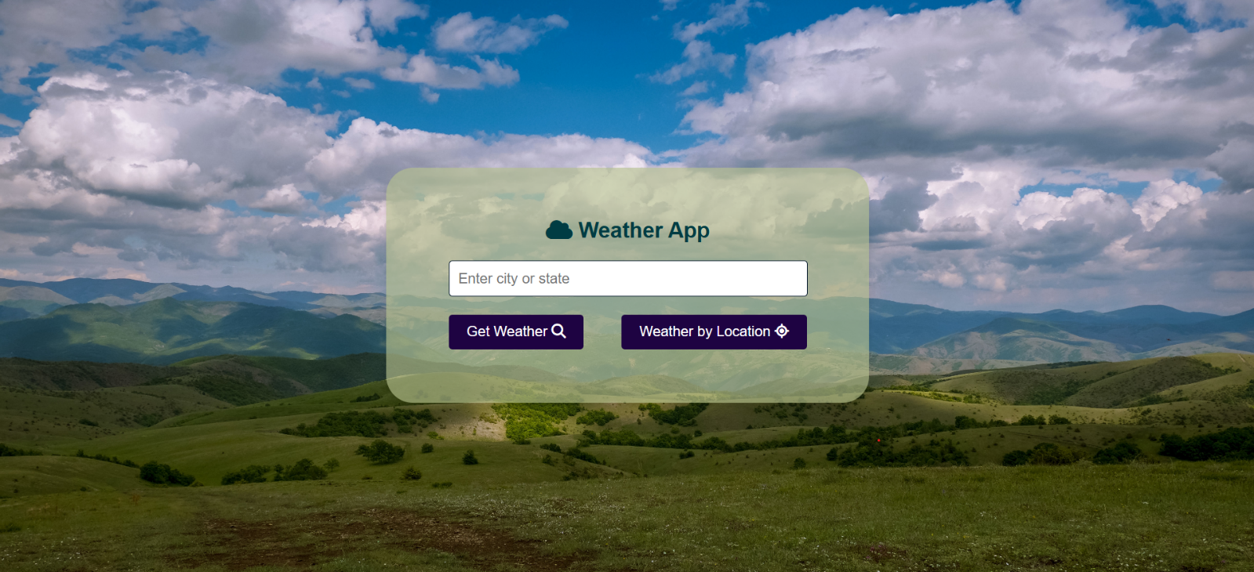**Skills Developed:** This task helped me understand how to interact with external APIs and manage asynchronous data fetching in JavaScript.

**BACKGROUND INFORMATION OF YOUR PROJECT**

**Prodigy InfoTech** is a prominent company based in Mumbai, Maharashtra, India, known for transforming the way people learn. The company is committed to creating innovative and accessible learning solutions that cater to people of all ages, backgrounds, and professions. Prodigy InfoTech’s mission is to enhance learning experiences through technology, providing educational tools that empower individuals to achieve their full potential. Whether it's helping students improve their academic performance, enabling professionals to upskill, or offering organizations advanced employee training programs, Prodigy InfoTech has been at the forefront of developing creative learning solutions.

**About My Internship at Prodigy InfoTech**

As an intern at Prodigy InfoTech, I had the opportunity to work on various web development tasks, contributing to the development of several interactive and user-friendly applications. My role involved designing and implementing front-end solutions, enhancing user experiences, and integrating functionalities that would support the company's mission of providing educational and practical tools for its users. The projects I worked on were aimed at improving the digital presence of Prodigy InfoTech and showcasing my development skills in real-world applications.

**Key Projects I Worked On:**

1. **Landing Page: Life of a Girl – Butterfly Stages.**

The landing page was designed to visually represent the metaphor of a girl’s life through the stages of a butterfly, symbolizing growth, transformation, and learning. This task provided me with hands-on experience in creating aesthetically pleasing and interactive web designs.

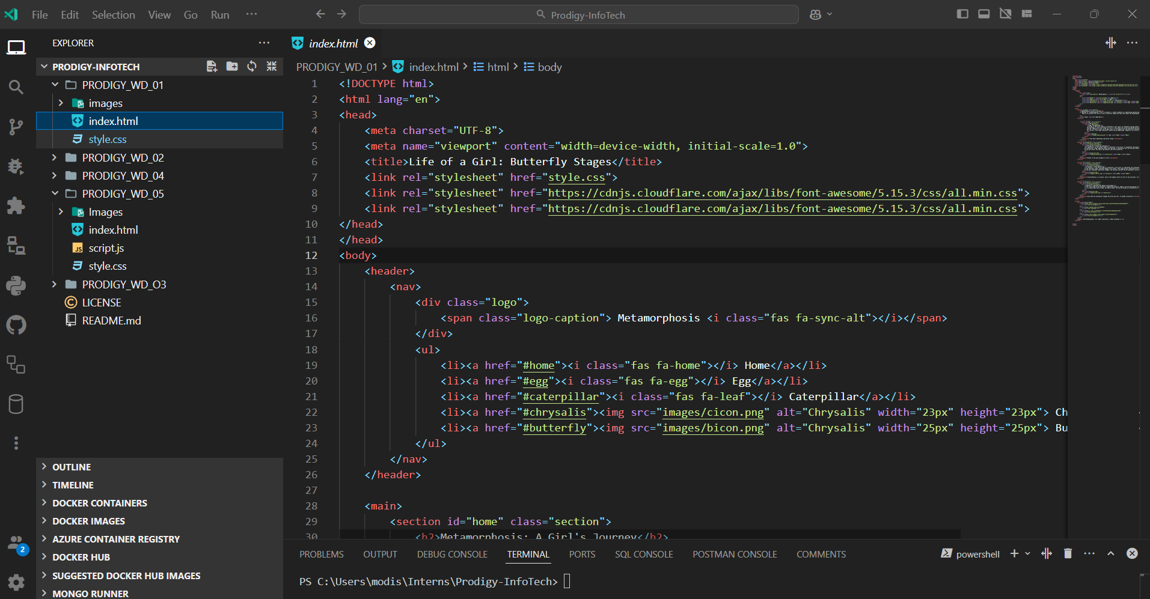

1. **Stopwatch Application**

The stopwatch application was a simple, yet practical project built with HTML, CSS, and JavaScript. This task allowed me to explore JavaScript functionality in web applications, focusing on time-based user interactions.

1. **Tic-Tac-Toe Game**

The Tic-Tac-Toe game was an exciting project that involved creating an interactive game where users could play against each other or the computer. This project provided experience in handling user inputs, implementing logic, and using JavaScript for game development.

1. **Portfolio Website**

Creating my own portfolio website helped me consolidate my skills as a web developer. It provided a platform to showcase my previous work, demonstrate my technical abilities, and highlight my professional achievements.

1. **Weather App**

The weather app was designed to fetch real-time weather information based on user input. This project enabled me to work with APIs and real-time data fetching, providing insight into integrating third-party services into web applications.

**Importance of the Projects:**

Each of the tasks I worked on during my internship played a vital role in helping me develop practical web development skills while contributing to Prodigy InfoTech’s mission of providing innovative learning solutions. The projects also provided me with the opportunity to work on responsive and interactive web pages, gain experience with APIs, and understand the significance of creating intuitive user interfaces. These projects were integral in enhancing my knowledge of front-end development and user experience design, which are crucial for developing successful web applications.

**CHAPTER 1**

**INTRODUCTION**

In the modern era, web development plays an essential role in how businesses, organizations, and individuals create and manage their digital presence. It is a field that spans a wide array of tasks, from designing visually appealing websites to creating complex, interactive applications. With the increasing importance of the internet and digital technologies, the demand for skilled web developers has grown exponentially. The field of web development includes both **front-end** and **back-end** development, with front-end development focusing on the visual and interactive elements of websites and applications.

**1.1 Introduction to Prodigy InfoTech and My Internship Experience**

During my internship at **Prodigy InfoTech**, I was given the opportunity to work on several projects that were crucial to the company’s mission of transforming the way people learn. Prodigy InfoTech is based in Mumbai, Maharashtra, and is committed to developing innovative and accessible learning solutions for a wide variety of users, including students, professionals, and organizations. The company focuses on creating educational tools that are designed to empower people and help them achieve their full potential.

As an intern at Prodigy InfoTech, I had the privilege of contributing to the development of interactive and user-friendly web applications. The internship provided me with an invaluable learning experience where I applied my knowledge of web development to create functional and aesthetically pleasing applications. I was involved in designing and implementing front-end solutions that not only enhanced the visual appeal of the website but also improved user experience and engagement.

**1.2 Overview of My Role as an Intern**

My role as a web development intern was primarily focused on front-end development tasks. I worked closely with senior developers and designers, contributing to various stages of project development, from planning and design to implementation and testing. I was responsible for creating web pages that were both visually appealing and fully functional, ensuring that they were responsive and accessible across various devices.

The tasks I worked on allowed me to improve my skills in **HTML**, **CSS**, **JavaScript**, and other key web technologies. In addition, I had the opportunity to explore **API integration** and learn how to incorporate real-time data into web applications, which added a dynamic and interactive component to the projects.

**1.3 My Internship Projects**

The internship consisted of several significant tasks that allowed me to showcase my skills and creativity. Each project presented its own set of challenges, but they all contributed to my growth as a web developer.

**1.4 Introduction to Web Development**

Web development is the process of creating and maintaining websites and web applications that are accessible over the internet. It involves a combination of tasks, from designing the layout and user interface to implementing functionality and ensuring the site runs smoothly. Web development can be broken down into two main categories: **front-end development** and **back-end development**.

**1. Front-End Development**

Front-end development is concerned with what users see and interact with on a website. It focuses on the layout, design, and user experience (UX). The primary tools used in front-end development include:

* **HTML (HyperText Markup Language):** The foundation of web pages, HTML is used to structure the content and elements on the page.
* **CSS (Cascading Style Sheets):** CSS controls the look and feel of the website, including colors, fonts, and layout.
* **JavaScript:** JavaScript is used to make websites interactive, allowing for dynamic content updates, form validation, animations, and more.

**1.5 Importance of Web Development**

Web development is not only crucial for creating websites but also plays a vital role in various sectors, providing individuals and organizations with opportunities to establish a digital presence, interact with users, and grow their businesses. The importance of web development can be seen in several key areas:

**1. Business Growth and Digital Transformation**

* Web development enables businesses to establish an online presence, reach a global audience, and expand their customer base. Websites, e-commerce platforms, and web applications allow businesses to engage with customers, sell products, and improve brand visibility.
* The rise of digital platforms has transformed the way businesses operate, making web development essential for companies of all sizes.

**2. Global Accessibility**

* With an internet connection, anyone can access websites and web applications from anywhere in the world. This global accessibility creates a level playing field for businesses, organizations, and individuals to reach international audiences, provide services, and collaborate on a global scale.
* Web development ensures that websites are accessible across various devices, operating systems, and browsers, maximizing their reach.

**3. Enhanced User Experience**

* A key aspect of web development is ensuring that websites are user-friendly, intuitive, and visually appealing. By focusing on UX/UI design, web development contributes to an enhanced user experience, which is vital for customer retention, satisfaction, and engagement.
* Websites that are easy to navigate and responsive across different devices lead to higher conversion rates, whether for sales, leads, or other user actions.

**4. Innovation and Customization**

* Web development allows businesses to create custom solutions tailored to their specific needs. Whether it's a unique web application, a specialized e-commerce platform, or an online learning portal, web development enables innovation by providing the tools and technologies to create bespoke solutions.
* Customization allows businesses to differentiate themselves and provide value to their customers in unique ways.

**5. Job Opportunities and Career Growth**

* As the demand for web developers continues to grow, the field offers abundant job opportunities across various industries, from tech startups to large corporations. The skills gained through web development are highly transferable, offering career growth and mobility.
* Web development also provides the opportunity to work as a freelancer or entrepreneur, creating your own projects or solutions.

**6. Continuous Learning and Adaptation**

* Web development is a rapidly evolving field, with new technologies, tools, and best practices emerging regularly. This offers web developers the opportunity for continuous learning, skill enhancement, and staying ahead of industry trends.
* Developers can specialize in various areas, such as front-end development, back-end development, mobile app development, or even full-stack development, leading to diverse career paths.

**7. Social and Educational Impact**

* Web development plays a critical role in education by enabling online learning platforms, digital classrooms, and virtual collaboration. In social sectors, web development allows organizations to reach broader audiences, spread awareness, and provide services to communities.
* Governments and non-profit organizations use web development to create public service platforms, making information and resources more accessible to citizens.

Bottom of Form

**CHAPTER 2**

**OBJECTIVES OF OUR PROJECT**

The objective of any project defines its scope, the goals it aims to achieve, and the outcomes expected from it. In this chapter, we will outline the key objectives of our project, focusing on web development, and particularly the various tasks we undertook during our internship.

**1. To Develop Functional Web Applications**

* **Objective:** Create web applications that offer essential features and functionality, ensuring the proper working of each application.
* **Importance:** The primary goal of any web development project is to build functional, user-friendly applications. This allows users to perform tasks like tracking time, playing games, or managing information easily.

**2. To Enhance Front-End Development Skills**

* **Objective:** Improve the design and user interaction aspects of each project using HTML, CSS, and JavaScript.
* **Importance:** A critical objective of the internship was to enhance front-end development skills. This included learning how to build visually appealing, interactive, and responsive websites that deliver an exceptional user experience across different devices.

**3. To Implement Responsive Web Design**

* **Objective:** Ensure that all projects are fully responsive, meaning they can adapt and function well across various screen sizes, from desktops to smartphones.
* **Importance:** Responsive design is crucial in today's multi-device world. It guarantees that applications are accessible and usable by users, regardless of the device they are using.

**4. To Develop and Manage Backend Functionality (For Relevant Projects)**

* **Objective:** Build and manage server-side functionality for dynamic web applications, such as handling user requests and integrating with databases.
* **Importance:** While some of the projects were focused on front-end design, others required back-end functionality, where the main objective was to ensure seamless data management and processing, leading to an integrated user experience.

**5. To Foster Problem-Solving and Analytical Thinking**

* **Objective:** Strengthen logical thinking and problem-solving abilities through tasks such as building calculators, stopwatches, and interactive games.
* **Importance:** Problem-solving is a core aspect of web development. This objective aimed to improve analytical skills by working on projects that required creating logic-based solutions, such as handling user inputs and performing calculations.

**6. To Gain Experience in Building Full-Stack Web Applications**

* **Objective:** Work on creating complete, full-stack web applications that include both front-end and back-end components.
* **Importance:** Developing full-stack applications is crucial for modern web developers, as it provides a comprehensive understanding of how both sides of a web application work together. This objective aimed to provide real-world experience in handling both the front and back ends of web development.

**7. To Optimize Website Performance**

* **Objective:** Ensure that websites are optimized for speed, efficiency, and performance, improving load times and user experience.
* **Importance:** Website performance plays a critical role in user retention and satisfaction. The goal here was to implement best practices that reduce load times and enhance website speed, making them more efficient and enjoyable for users.

**8. To Improve Knowledge of Web Security Best Practices**

* **Objective:** Incorporate security best practices into the development process to ensure the protection of user data and prevent common vulnerabilities.
* **Importance:** Web security is a critical aspect of modern web development. This objective aimed to provide knowledge on how to build secure websites that protect user information and ensure a safe browsing experience.

**9. To Develop Practical Skills in API Integration**

* **Objective:** Learn how to integrate third-party services via APIs to enhance the functionality of web applications, such as integrating weather data or payment gateways.
* **Importance:** Many modern web applications rely on APIs to add additional features and data sources. This objective aimed to provide hands-on experience in integrating APIs, a key skill for developers in the current web development landscape.

**10. To Deliver Well-Designed Portfolio Projects**

* **Objective:** Build a professional portfolio website that showcases skills, achievements, and projects in an engaging and organized manner.
* **Importance:** A personal portfolio website is an essential tool for showcasing web development skills. This objective was geared towards creating a comprehensive, visually appealing portfolio that highlights the various projects completed during the internship.

**11. To Gain Real-World Experience in Web Development**

* **Objective:** Apply theoretical knowledge to real-world web development projects, gaining hands-on experience with industry-standard tools and practices.

**CHAPTER 3**

**ISSUES FOR IMPLEMENTING**

While working on various projects during the internship, several challenges were encountered, particularly in terms of the technical and functional implementation of each task. These issues needed to be addressed effectively to ensure that the web applications were functional, user-friendly, and responsive. Below are the key issues encountered during the implementation phase of each project.

**1. Designing a Visually Appealing and Responsive Layout (Landing Page)**

* **Issue:**
  + Creating a visually attractive layout for the "Life of a Girl: Butterfly Stages" landing page that was also responsive on various screen sizes was challenging. Ensuring that the page looked good on both large screens and smaller mobile devices required attention to design details and proper use of CSS media queries.
* **Solution:**
  + Utilized flexible grid systems and CSS media queries to create a responsive design. Ensured that all elements scaled properly across screen sizes, from mobile devices to large monitors, without compromising on the user experience or aesthetics.

**2. Handling JavaScript Logic for Stopwatch (Stopwatch)**

* **Issue:**
  + Implementing the logic for the stopwatch, including the start, stop, and reset functionalities, posed difficulties in controlling timing accuracy and ensuring that the stopwatch worked continuously without errors. The need for precise time calculations and smooth transitions added to the complexity.
* **Solution:**
  + Used JavaScript’s setInterval() and clearInterval() functions to handle time increments effectively. Ensured accurate calculations by thoroughly testing and debugging the timing functions to prevent errors such as improper stop or reset behavior.

**3. Managing Game Logic and User Interaction (Tic-Tac-Toe)**

* **Issue:**
  + Building the Tic-Tac-Toe game with AI and multiplayer functionality involved managing multiple game states and interactions. The AI needed to make intelligent moves, and managing the game state (who wins, who’s turn it is, etc.) required a solid understanding of JavaScript logic.
* **Solution:**
  + Used JavaScript to manage the game state, track player moves, and implement AI logic with simple algorithms for decision-making. To enhance the user experience, I ensured the interface updated dynamically and showed the game status clearly.

**4. Optimizing the Portfolio Website for Performance (Portfolio Website)**

* **Issue:**
  + Ensuring that the portfolio website was optimized for fast loading times and smooth performance while maintaining high-quality images, animations, and content was a key challenge. Balancing visual appeal and performance required optimizations.
* **Solution:**
  + Optimized images for web use by reducing file sizes without losing quality. Applied lazy loading for images and content that didn’t need to load immediately. Implemented smooth scrolling and animations while ensuring that they didn’t negatively affect page load times.

**5. Fetching and Displaying Real-Time Weather Data (Weather App)**

* **Issue:**
  + One of the significant challenges in developing the Weather App was integrating with external weather APIs to fetch real-time data. Ensuring that the app displayed the correct data based on user input, handled API errors, and provided a smooth user experience was a challenge.
* **Solution:**
  + Integrated an external weather API (e.g., OpenWeatherMap API) and used JavaScript to fetch and display the real-time data. Managed asynchronous operations using fetch() and async/await to ensure the weather information was retrieved and displayed correctly without blocking the user interface.

**6. Cross-Browser Compatibility Issues**

* **Issue:**
  + One of the recurring issues faced across all projects was ensuring compatibility across different browsers. Some web elements, such as CSS animations and flexbox layouts, did not work uniformly across all browsers, leading to inconsistencies in the user interface.
* **Solution:**
  + Used browser compatibility tools and testing to identify issues in different browsers. Applied CSS prefixes for features that required browser-specific styling and used fallback styles to ensure consistent behavior across all major browsers.

**7. UI/UX Design Challenges**

* **Issue:**
  + While working on the Portfolio and Weather App projects, ensuring a user-friendly design and intuitive navigation presented a challenge. In particular, balancing the design’s aesthetic appeal with functionality was an area that needed careful thought.
* **Solution:**
  + Focused on simplifying the user interface while ensuring a clean, attractive design. For the weather app, I used clear icons and readable text to make the app easy to understand at a glance. The portfolio was designed with smooth navigation and interactive animations to engage users.

**8. Debugging JavaScript Errors**

* **Issue:**
  + Debugging complex JavaScript functions, especially in projects like Tic-Tac-Toe and the stopwatch, was often challenging. Tracking down logical errors or misbehaving functions was time-consuming, especially when multiple functions interacted with each other.
* **Solution:**
  + Used browser developer tools for efficient debugging, logging variables, and checking the flow of code. Through systematic testing, I identified errors and corrected them to ensure smooth functionality across the projects.

**9. Ensuring Seamless API Integration (Weather App)**

* **Issue:**
  + Integrating the weather API required correct handling of asynchronous requests and ensuring that errors (such as invalid locations or API downtime) were properly handled and did not crash the app.
* **Solution:**
  + Used JavaScript’s try-catch blocks to handle potential errors when fetching data from the API. Also implemented loading indicators to improve user experience during data retrieval, ensuring a seamless flow even in case of delays.

**CHAPTER 4**

**SOLUTION APPROACH OF YOUR PROJECT**

**General Solution Strategy Across All Projects**

The solution approach for each project combined a clear understanding of the task requirements, a structured development process, and the use of modern web development technologies. By breaking down the projects into manageable components, maintaining a user-first approach, and continuously testing and debugging, each project was successfully implemented with attention to functionality, design, and performance. The solution approaches ensured that all tasks, from building a portfolio website to integrating a weather API, were completed with efficiency and quality, contributing to the overall success of the internship experience.

1. **Clear Planning and Requirement Gathering:**
   * Before starting any project, the first step was always to analyze the requirements and objectives. For instance, when working on the landing page, I thoroughly researched the metaphorical concept to ensure it was effectively represented in the design. Similarly, for the weather app.
2. **Breaking Down Tasks:**
   * The projects were broken down into smaller, manageable tasks. For example, with the Tic-Tac-Toe game, I first focused on creating the grid and functionality for player input before integrating AI logic. This modular approach made the process more structured and efficient.
3. **User-Centric Design:**
   * All projects, from the stopwatch to the weather app, were designed with the user in mind. UI/UX principles were followed to ensure that the applications were easy to navigate, intuitive, and responsive on various devices.
4. **Testing and Debugging:**
   * Continuous testing was essential throughout the development process. For projects involving JavaScript logic (like the stopwatch or Tic-Tac-Toe game), unit testing was performed to ensure that all functions (start, stop, reset, etc.) worked correctly. In case of bugs, debugging tools and the browser console were used to troubleshoot and resolve issues.
5. **Ensuring Cross-Browser Compatibility:**
   * To ensure that the web applications were accessible to a wider audience, all projects were tested on multiple browsers. CSS prefixes and fallbacks were used to ensure that the visual elements rendered correctly across different platforms.
6. **Optimization and Performance:**
   * For the portfolio website and weather app, performance optimization was a key consideration. This included optimizing images, using lazy loading for content, and reducing the size of JavaScript files to enhance page load speed and overall user experience.

**CHAPTER 5**

**CHALLENGES AND RESOLUTIONS**

While working on the various web development tasks and projects during my internship, I encountered multiple challenges specific to web design and functionality. These challenges were directly related to the projects, ranging from simple functionality issues to complex design and performance concerns. Below, I will outline the key challenges I faced in each project and the resolutions I applied to solve them.

**1. Landing Page (Life of a Girl - Butterfly Stages)**

* Challenge**:** Designing an interactive, responsive layout.
  + Resolution**:** Used CSS animations and Flexbox/Grid for responsive design, ensuring smooth scrolling and appealing visuals.

**2. Stopwatch Application**

* Challenge**:** Synchronizing timer and handling UI responsiveness.
  + Resolution**:** Utilized setInterval() and clearInterval() for accurate timing; used CSS Flexbox for a responsive layout across devices.

**3. Tic-Tac-Toe Game**

* Challenge**:** Implementing AI and handling game logic.
  + Resolution**:** Developed a basic AI algorithm for blocking and winning; ensured proper game reset and draw logic.

**4. Portfolio Website**

* Challenge**:** Cross-browser compatibility and performance optimization.
  + Resolution**:** Applied browser-specific prefixes and fallback solutions; optimized animations using CSS transitions for smooth performance.

**5. Weather Application**

* Challenge**:** Integrating the weather API and displaying dynamic data.
  + Resolution**:** Used fetch() API for data handling; implemented error handling and UI responsiveness using media queries.

**6. General Challenges:**

* ResponsiveDesign**:** Ensured seamless experiences across devices using Flexbox, Grid, and media queries.
* Performance**:** Optimized page load and animations by reducing HTTP requests and compressing media files.
* overcoming these challenges enhanced my skills and provided valuable experience in tackling real-world web development issues.

**CHAPTER 6**

**LEARNING OUTCOMES**

Throughout my internship at Prodigy InfoTech, I gained valuable skills and practical knowledge in web development. Below are the key learning outcomes:

**1. Improved Technical Skills**

* Front-End Development: I strengthened my proficiency in HTML, CSS, and JavaScript, building interactive and responsive websites.
* UI/UX Design: I learned how to design visually appealing and user-friendly interfaces. For example, creating smooth scrolling and intuitive layouts in the landing page and portfolio website.
* API Integration: In the weather application, I gained experience in fetching real-time data from external APIs, handling asynchronous operations, and displaying dynamic content.

**2. Problem-Solving Abilities**

* Debugging and Optimization: I learned how to troubleshoot issues, optimize performance, and ensure cross-browser compatibility. I overcame challenges like ensuring responsive layouts and reducing page load times.
* Game Logic Implementation: The Tic-Tac-Toe project improved my problem-solving skills as I implemented game rules, AI algorithms, and proper game state management.

**3. Responsive Web Design**

* I learned how to design and develop websites that work seamlessly across devices (desktops, tablets, and mobiles) by using responsive web design techniques such as Flexbox, Grid, and media queries.

**4. Project Management**

* I learned how to work on multiple projects simultaneously, manage deadlines, and maintain a balance between learning and execution. This improved my time management and organizational skills.

1. **Practical Application of Web Development Principles**

* Through the tasks like creating landing pages, calculators, and portfolio websites, I applied core web development principles in real-world scenarios, which deepened my understanding of concepts like web layout, interactive elements, and user experience.

1. **Enhanced Creativity and Design Thinking**

* Designing the landing page and portfolio website allowed me to unleash my creativity, learning the importance of aesthetics, design patterns, and user engagement in web development.

In summary, this internship helped me develop not just technical skills but also valuable problem-solving, creativity, and project management abilities that will be crucial for my future endeavors in the field of web development.

**CHAPTER 7**

**SELF-ASSESSMENT**

Reflecting on my internship at Prodigy InfoTech, I have gained significant insights into my strengths and areas for improvement. Here's my self-assessment based on the tasks I completed during this period:

* 1. **Strengths**
* Technical Skills:

I believe my proficiency in front-end technologies like HTML, CSS, and JavaScript has improved significantly. I was able to build responsive, interactive, and visually appealing web pages and applications.

* Problem-Solving:  
  Throughout the internship, I demonstrated strong problem-solving skills, especially while working on the Tic-Tac-Toe game and integrating the weather API. I successfully resolved issues related to game logic, AI, and dynamic content display.
* Creativity:  
  I displayed a high level of creativity while designing the landing page and portfolio website. I focused on the user experience and ensured the UI/UX designs were engaging and functional.
* Time Management:  
  I was able to balance multiple tasks and meet deadlines effectively, whether working on the landing page, portfolio, or weather app. I planned and executed each project efficiently, which improved my ability to prioritize and manage my time.
  1. **Personal Growth and Reflection**
* Adaptability:  
  This internship helped me become more adaptable to new environments and tasks. I had to quickly understand different projects, tackle challenges, and learn new concepts on the go.
* Confidence in Web Development:  
  I gained confidence in my ability to design and build web applications. The hands-on experience allowed me to grow as a web developer and gave me a solid foundation to build upon in my future career.
  1. **Areas for Improvement**
* Backend Development:

While I gained solid front-end experience, I feel I need more exposure to backend technologies and full-stack development. Understanding server-side frameworks, databases, and APIs in more depth would improve my overall web development skills.

* Advanced JavaScript Concepts:

Although I worked with JavaScript throughout the tasks, I could benefit from further understanding advanced JavaScript concepts like asynchronous programming, closures, and ES6+ features to write more efficient and clean code.

**CHAPTER 8**

**CONCLUSION**

My internship at Prodigy InfoTech has been an enriching experience, allowing me to grow both professionally and personally. The projects I worked on, including the landing page, stopwatch, Tic-Tac-Toe game, portfolio website, and weather app, provided me with a well-rounded exposure to web development. Each task challenged me to apply theoretical knowledge to practical scenarios, enhancing my technical and problem-solving skills.

This journey was instrumental in helping me understand the core aspects of front-end development, such as creating responsive layouts, integrating APIs, and implementing interactive features. I also learned the importance of UI/UX design in delivering a seamless user experience, which I applied to each project.

The internship not only helped me gain technical expertise but also honed my soft skills, such as time management, creativity, and adaptability. It gave me an opportunity to contribute to Prodigy InfoTech’s mission of delivering innovative learning solutions, aligning my work with real-world business goals.

In conclusion, this internship was a stepping stone in my career as a web developer, equipping me with the skills and confidence to tackle future challenges. I am grateful for the opportunity to learn, create, and grow in a professional environment. The experience has solidified my passion for web development and prepared me for further exploration and contributions in this field.

**REFERENCES**

1. **HTML, CSS, and JavaScript Documentation**

<https://developer.mozilla.org/en-US/docs/Web/HTML>

1. **Responsive Design**

<https://developer.mozilla.org/en-US/docs/Web/CSS>

1. **Web Development Trends**

<https://developer.mozilla.org/en-US/docs/Web/JavaScript>

<https://www.w3schools.com/>

1. **Weather API Documentation**

<https://openweathermap.org/api>